


UNIVERSITY INSTITUTE OF COMPUTING
MINI PROJECT
ON
Digital Lifestyle & Academic Performance Analysis using Excel
Program Name: BCA
Subject Name/Code: Data Science Lab Using Excel (24CAP-258)

Submitted by: Submitted to:
Name: Sarabjeet kaur Name: Pratham Sharma Name: Mr Arvinder Singh
UID: 24BCA10197 UID: 24BCA Designation: Assistant Professor
Section: 24BCA 2 Section: 24BCA 2 D.O.Submission:
Group: A Group: A Sign:
GitHub: GitHub:

ACKNOWLEDGEMENT

I would like to express my heartfelt gratitude to my respected teacher, whose constant guidance, encouragement, and valuable suggestions helped me in the successful completion of this project titled “Digital Lifestyle & Academic Performance Analysis using Excel.” Their continuous support and motivation made it possible for me to understand the concepts of data science and apply them practically using Microsoft Excel.
I am also deeply thankful to my school for providing me with the opportunity to work on such an informative and practical project. This project has enhanced my knowledge and skills in data collection, data analysis, and data visualization, which are very important in today’s digital world.
I would like to extend my sincere thanks to my parents for their moral support, patience, and encouragement throughout the completion of this project. Their support helped me stay focused and complete my work on time.
I also thank my friends and classmates who helped me in collecting the required data and gave useful suggestions for improving the quality of this project. Their cooperation made the data collection process easier and more efficient.
Lastly, I would like to thank everyone who directly or indirectly contributed to the completion of this project. This project has been a great learning experience for me, and it has helped me understand the practical application of Excel in data science.

INTRODUCTION
In today’s modern world, data plays a very important role in every field, including education, business, healthcare, and technology. The process of collecting, organizing, analyzing, and interpreting data to extract useful information is known as Data Science. It helps in making better decisions, identifying patterns, and predicting future outcomes.
With the rapid growth of technology, students are increasingly using digital devices such as smartphones, laptops, and tablets. While these devices provide access to educational resources, they also lead to increased screen time and social media usage. These lifestyle habits can significantly affect a student’s academic performance, concentration, and overall health.
Microsoft Excel is one of the most commonly used tools for data analysis. It is a powerful software that allows users to store large amounts of data in an organized manner and perform calculations using formulas and functions. Excel also provides features like sorting, filtering, and chart creation, which make it easier to analyze and visualize data.
In this project, Excel is used as a data science tool to study the relationship between students’ lifestyle habits and their academic performance. The data collected includes study hours, screen time, sleep duration, social media usage, attendance, and marks. By analyzing this data, we can identify patterns and understand how different factors influence students’ results.
The main focus of this project is to examine how daily habits such as study time, screen exposure, and sleep affect students’ academic outcomes. For example, students who spend more time studying and maintain a balanced routine are expected to perform better in their exams. On the other hand, excessive screen time and lack of sleep may negatively impact their performance.
This project also highlights the importance of maintaining a healthy balance between digital usage and academic activities. By using Excel functions such as AVERAGE, SUM, COUNTIF, IF, and VLOOKUP, meaningful insights can be derived from the collected data. These insights help in understanding trends and making informed conclusions.
Another important aspect of this project is data visualization. Charts such as bar graphs, pie charts, and line graphs are used to represent data in a visual format. This makes it easier to understand complex information and identify relationships between different variables.
Overall, this project demonstrates how Excel can be effectively used as a data science tool to analyze real-life problems. It also helps in developing analytical thinking, problem-solving skills, and technical knowledge. The findings of this project can help students become more aware of their lifestyle habits and encourage them to adopt healthier and more productive routines.
OBJECTIVES
The main objective of this project is to analyze the relationship between students’ digital lifestyle habits and their academic performance using Microsoft Excel. In today’s digital age, students spend a significant amount of time on electronic devices, which may influence their studies either positively or negatively. Therefore, this project aims to study these effects in a systematic and analytical manner.
One of the primary objectives is to understand how different factors such as study hours, screen time, sleep duration, and social media usage impact students’ marks. By collecting and analyzing this data, we aim to identify patterns and trends that can explain variations in academic performance among students.
Another important objective is to develop practical knowledge of Microsoft Excel as a data analysis tool. This includes learning how to organize data in tabular form, apply formulas and functions like AVERAGE, SUM, IF, COUNTIF, and VLOOKUP, and perform calculations efficiently. The project also aims to enhance skills in sorting, filtering, and managing data effectively.
The project further aims to use data visualization techniques such as bar charts, pie charts, line graphs, and scatter plots to represent data in a clear and understandable manner. Visual representation helps in identifying trends quickly and makes the analysis more meaningful.
Additionally, this project seeks to promote awareness among students about maintaining a balanced lifestyle. By analyzing the collected data, students can understand how excessive screen time or lack of sleep can negatively affect their academic performance, while proper study habits and good attendance can lead to better results.
Overall, the objective of this project is not only to perform data analysis but also to develop analytical thinking, improve technical skills, and encourage students to adopt healthier and more productive habits.
TOOLS USED:
Microsoft Excel
Functions: SUM, AVERAGE, IF, COUNTIF, VLOOKUP
Charts: Bar, Pie, Line, Scatter

DATA COLLECTION
Data collection is one of the most important steps in any data science project, as the accuracy and reliability of the results depend on the quality of the collected data. For this project, data was collected from a group of 13 students to analyze their lifestyle habits and academic performance.
The data was gathered using a simple survey method. Students were asked a set of questions related to their daily routine and academic activities. These questions included the number of hours they spend studying each day, the amount of time they spend on screens such as mobile phones or laptops, their average sleep duration, time spent on social media, their attendance percentage, and their academic marks.
The survey was designed in a structured format to ensure that the data collected was consistent and easy to analyze. All responses were recorded in numerical form wherever possible to make calculations easier in Excel. For example, study hours, screen time, and sleep were recorded in hours, while attendance and marks were recorded in percentages.
The collected data represents a small sample of students and is used for analysis purposes only. Although the sample size is limited, it provides useful insights into the relationship between lifestyle habits and academic performance.
After collecting the data, it was carefully entered into Microsoft Excel in a tabular format. Each column represents a specific variable such as study hours or marks, and each row represents an individual student. This structured format makes it easier to apply formulas, perform analysis, and create charts.
Thus, the data collection process in this project was systematic, organized, and focused on gathering relevant information required for meaningful analysis.

DATA CLEANING
Data cleaning is an essential step in the data analysis process, as it ensures that the data is accurate, consistent, and free from errors. Before performing any calculations or analysis in Excel, it is important to carefully check and prepare the data.
In this project, the collected data was first reviewed to identify any missing or incorrect values. All entries were checked to ensure that there were no blank cells or incomplete information. Since the data was collected in a structured format, there were no missing values, which made the analysis process easier.
Next, the data was examined for consistency. All numerical values such as study hours, screen time, sleep duration, attendance, and marks were verified to ensure they were in the correct format. For example, all time-related values were recorded in hours, and percentages were used for attendance and marks. This uniformity helps in performing accurate calculations using Excel formulas.
Duplicate entries were also checked and removed, although no duplicates were found in this dataset. Ensuring that each row represents a unique student is important to avoid incorrect analysis results.
Another important step in data cleaning is correcting any data entry errors. All values were cross-checked to ensure they were realistic and within a reasonable range. For instance, study hours and sleep duration were verified to ensure they were not unusually high or low.
Finally, the data was properly formatted in Excel with clear column headings and aligned values. This improves readability and makes it easier to apply functions, sort data, and create charts.
In conclusion, data cleaning helps in improving the quality of the dataset and ensures that the results obtained from analysis are accurate and reliable. It is a crucial step that forms the foundation of any successful data science project.

DATASET
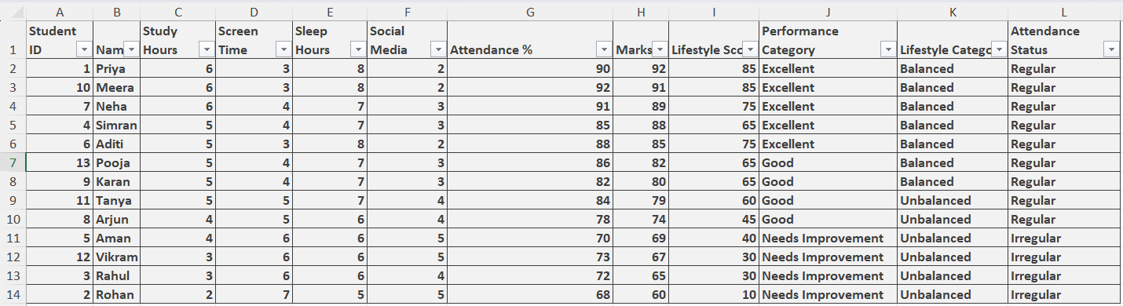
QUERY 1: Calculate Lifestyle Score
Combines study, sleep, and screen balance
=(C2*10)+(E2*5)-(D2*5)
Output:
- Higher score = better lifestyle
- Priya → high score
- Rohan → low score

QUERY 2: Calculate Percentage (Marks)
=H2
Marks already in percentage
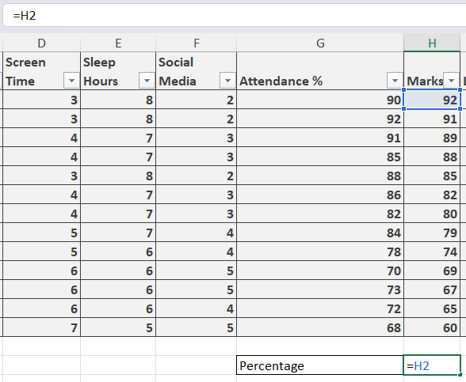
QUERY 3: Assign Performance Category (IF)
=IF(H2>=85,"Excellent",IF(H2>=70,"Good","Needs Improvement"))
Output:
- Priya → Excellent
- Rahul → Needs Improvement
QUERY 4: Assign Lifestyle Category (IF + AND)
=IF(AND(C2>=5,D2<=4,E2>=7),"Balanced","Unbalanced")
Output:
- Simran → Balanced
- Aman → Unbalanced

QUERY 5: Check Attendance Status
=IF(G2>=75,"Regular","Irregular")
QUERY 6: Find Top Performer (MAX + INDEX + MATCH)
=INDEX(B2:B14,MATCH(MAX(H2:H14),H2:H14,0))
Output: Priya
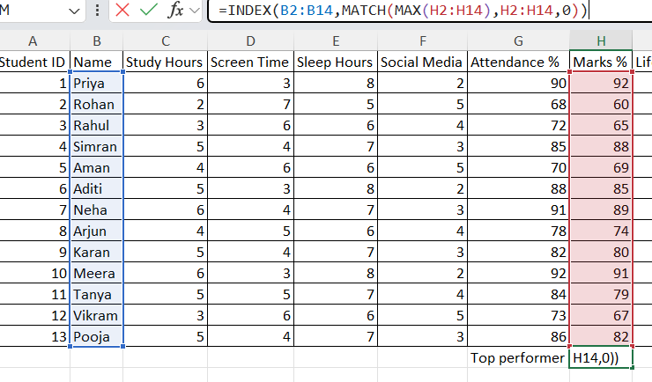
QUERY 7: Find Lowest Performer
=INDEX(B2:B14,MATCH(MIN(H2:H14),H2:H14,0))
Output: Rohan
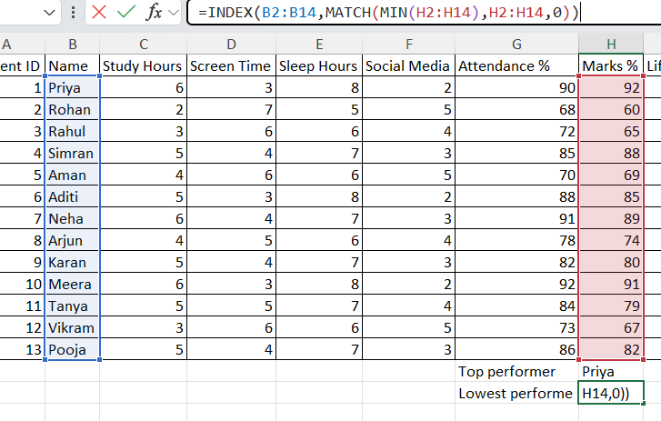
QUERY 8: Average Marks of Class
=AVERAGE(H2:H14)
Output: 77.69%
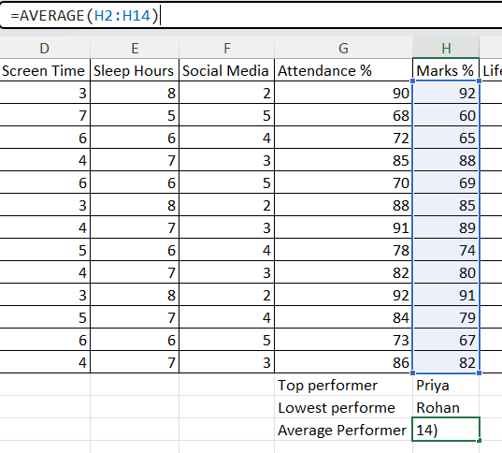
QUERY 9: Count High Screen Time Students (>5 hrs)
=COUNTIF(D2:D14,">5")
Output: 4 students
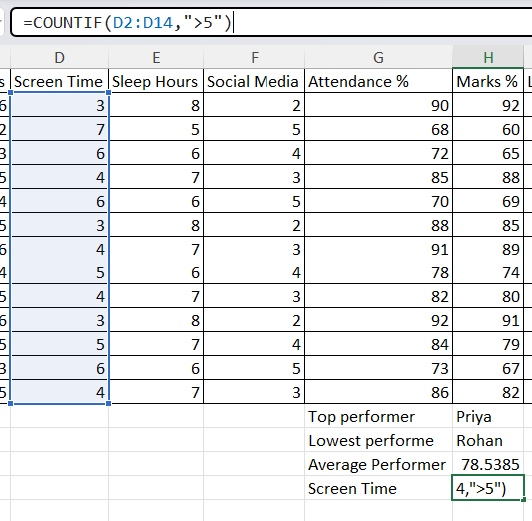

QUERY 10: Count Balanced Lifestyle Students
=COUNTIF(J2:J14,"Balanced")
Output: ~6
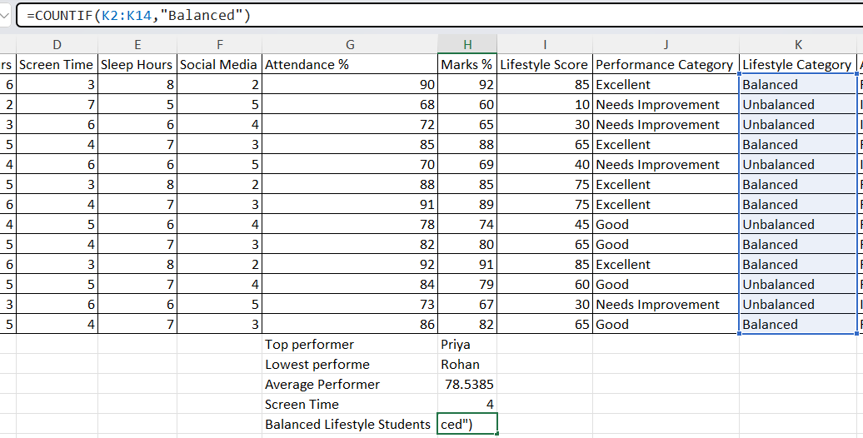
QUERY 11: VLOOKUP (Find Marks of a Student)
=VLOOKUP("Aditi",A2:H14,8,FALSE)
Output: 85
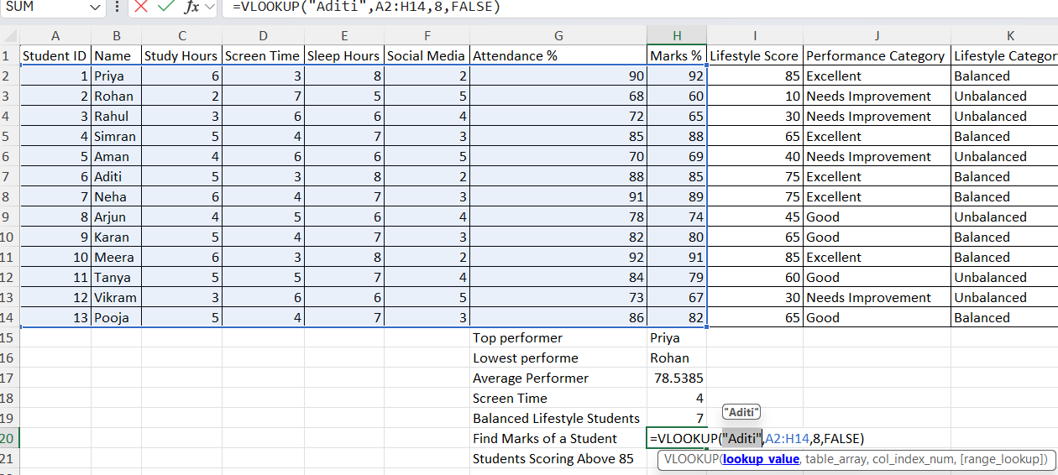

QUERY 12: Students Scoring Above 85 (COUNTIF)
=COUNTIF(H2:H14,">85")
Output: 4 students
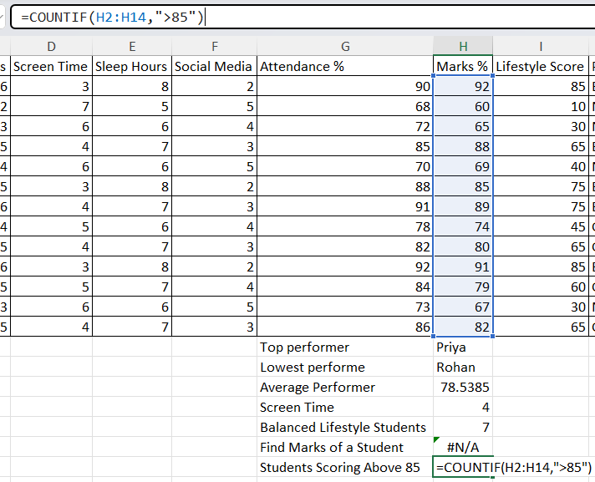
QUERY 13: Sort by Marks (Descending)
Excel Steps:
- Select data
- Sort → Largest to Smallest
Output:
- Priya at top
- Rohan at bottom
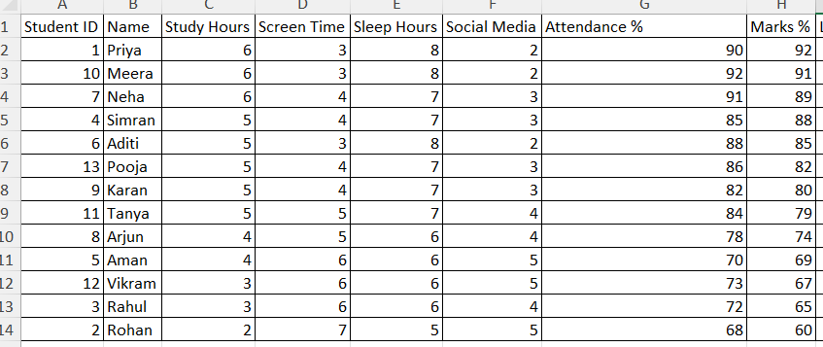
QUERY 14: Filter Unbalanced Lifestyle Students
Apply Filter:
- Lifestyle Category = "Unbalanced"
Output:
- Aman
- Rohan
- Rahul
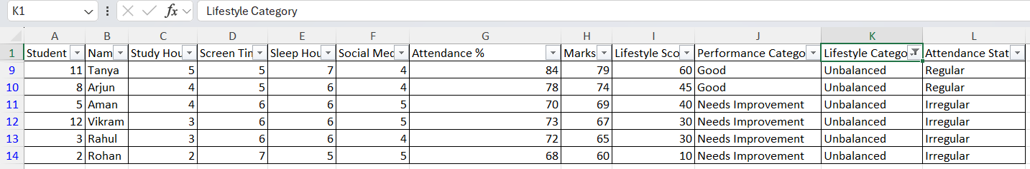
QUERY 15: Summary Report
- Total Students = 13
- Avg Marks = 77.69%
- Balanced Students = 6
- High Screen Users = 4
- Topper = Priya

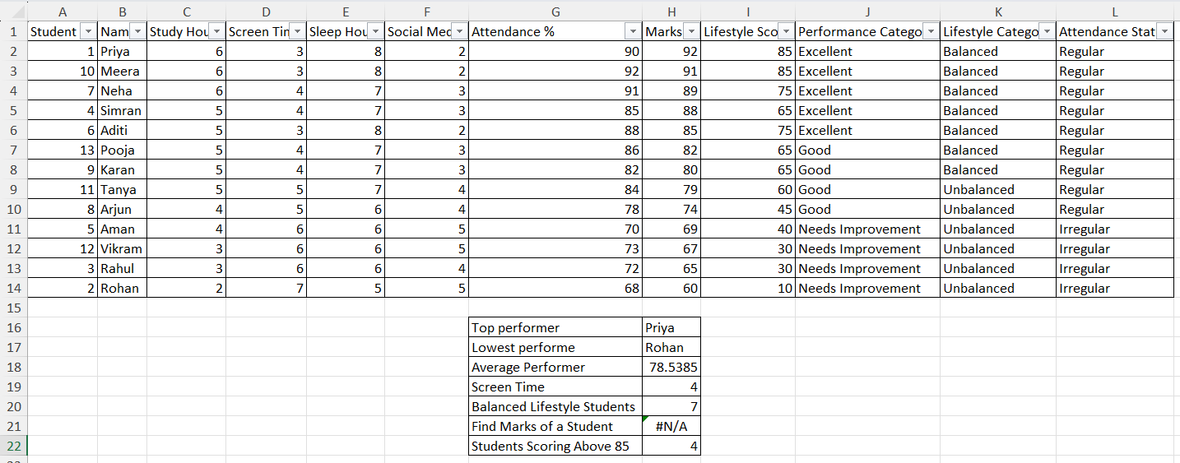
ADVANTAGES
The Digital Lifestyle & Academic Performance Analysis project offers several important advantages in understanding student behavior and improving academic outcomes. One of the major advantages of this project is that it helps in identifying the relationship between students’ daily habits and their academic performance. By analyzing factors such as study hours, screen time, sleep duration, and social media usage, it becomes easier to understand how these habits influence marks.
Another key advantage is that it provides a practical application of data science concepts using Microsoft Excel. Instead of only learning theory, this project allows students to apply formulas, functions, and data visualization techniques in real-life scenarios. This improves both technical and analytical skills.
The project also promotes better decision-making. With the help of charts and summary reports, it becomes easier to identify top-performing students, weak students, and those with unhealthy lifestyle habits. Teachers and students can use this information to make improvements.
Automation is another important benefit. Excel formulas such as IF, COUNTIF, AVERAGE, and VLOOKUP reduce manual calculations, saving time and minimizing errors. This increases efficiency and accuracy.
Additionally, the project helps in creating awareness among students about maintaining a balanced lifestyle. It clearly shows that students who manage their time well, sleep properly, and limit screen usage tend to perform better academically.
Overall, this project enhances data handling skills, improves understanding of student behavior, and demonstrates the importance of using technology for analysis.

LIMITATIONS OF THE PROJECT
Despite its usefulness, this project also has certain limitations. One of the main limitations is the small sample size. The data is collected from only 13 students, which may not represent the behavior of a larger group. Therefore, the results cannot be generalized for all students.
Another limitation is that the data is based on self-reported information. Students may not always provide completely accurate details about their study hours, screen time, or sleep duration. This can affect the accuracy of the analysis.
The project also uses basic Excel tools and functions. While Excel is powerful, it has limitations when dealing with very large datasets or advanced statistical analysis. More advanced tools like Python or specialized data science software can provide deeper insights.
Additionally, the project focuses on only a few lifestyle factors. There may be other important factors affecting academic performance, such as mental health, teaching methods, or family environment, which are not considered in this analysis.
Another limitation is that correlation does not always mean causation. Even if two variables appear related (for example, screen time and marks), it does not always mean one directly causes the other.
In conclusion, while the project provides useful insights, its findings should be interpreted carefully due to these limitations.

FEATURES IMPLEMENTED IN THE PROJECT
This project includes several important features that make it effective and practical for data analysis. One of the key features is data organization, where student data is arranged in a structured tabular format in Excel. This makes it easy to manage and analyze information.
Another important feature is the use of Excel formulas and functions. Functions such as SUM, AVERAGE, IF, COUNTIF, and VLOOKUP are used to perform calculations like marks analysis, categorization of students, and identifying trends. These functions help in automating the analysis process.
The project also includes data classification features. Students are categorized into different groups such as “Excellent,” “Good,” and “Needs Improvement” based on their marks. Similarly, lifestyle categories like “Balanced” and “Unbalanced” are created based on study hours, sleep, and screen time.
Data visualization is another major feature. Charts such as bar graphs, pie charts, and line graphs are used to represent the data visually. This makes it easier to understand patterns and relationships.
Filtering and sorting features are also implemented. These allow users to quickly identify top performers, weak students, or those with high screen time.
The project also includes a dashboard feature, which summarizes key information such as total students, average marks, and performance indicators in a single view. This improves clarity and presentation.
Overall, these features make the project interactive, efficient, and easy to understand.

CONCLUSION
In conclusion, the Digital Lifestyle & Academic Performance Analysis project successfully demonstrates the relationship between students’ daily habits and their academic performance. The analysis clearly shows that students who maintain a balanced lifestyle, including sufficient study hours, proper sleep, and limited screen time, tend to perform better in their academics.
The project also highlights the importance of using data science techniques in real-life situations. By using Microsoft Excel, large amounts of data were organized, analyzed, and interpreted effectively. Functions such as IF, COUNTIF, AVERAGE, and VLOOKUP helped in simplifying complex calculations and deriving meaningful insights.
Another important outcome of this project is the development of analytical and technical skills. It helped in understanding how data can be used to identify patterns, trends, and relationships. The use of charts and dashboards made the data more visually appealing and easier to understand.
Furthermore, the project creates awareness among students about the importance of managing their digital lifestyle. It encourages students to reduce unnecessary screen time, maintain proper sleep, and focus more on studies to achieve better results.
Although the project has some limitations, it still provides valuable insights and serves as a strong foundation for further analysis. Future studies can include more data and advanced tools to improve accuracy.
Overall, this project proves that Excel is a powerful and useful tool for data analysis and that maintaining a balanced lifestyle plays a crucial role in academic success.

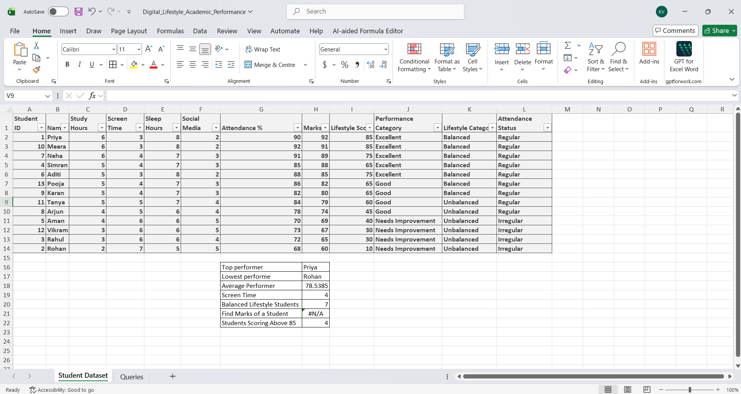
OUTPUT

